Joseph Dengler 04/15/2023

Item Frequency Analyzer

The Item Frequency Analyzer is a C++ program that reads a list of items from a file, calculates the frequency of each item, and provides various ways to display and save the frequency information. The code is organized into three separate files (Header.h, Functions.cpp, and Main.cpp) to ensure a modular and maintainable design.

Header.h contains the ItemFrequency class definition, including private member variables (items and frequencies arrays, count), private functions (loadDataFromFile), and public functions (constructor, getItemFrequency, printFrequencyList, printFrequencyHistogram, saveDataToFile).

Functions.cpp implements the ItemFrequency class functions, handling data loading, frequency calculations, and other operations. Finally, Main.cpp contains the main function, creating an ItemFrequency instance, displaying a menu, and managing user input. The program reads data from a file ("CS210_Project_Three_Input_File.txt") and stores items and frequencies in parallel arrays.

The program reads data from a file ("CS210_Project_Three_Input_File.txt") and stores the items and their frequencies in two parallel arrays (items and frequencies).

Shown below is the four menu options and what the user can see / choose from:

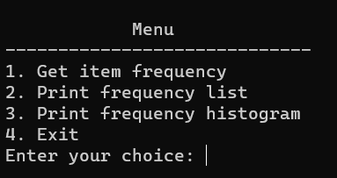

* Get item frequency: The user can input an item name, and the program will display the frequency of the given item. Below shows an example with string ‘Onions’:

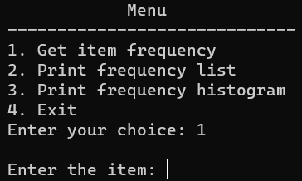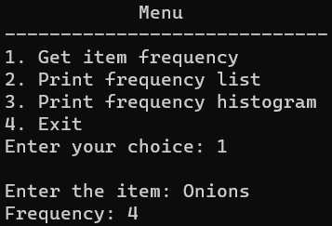

* + Print frequency list: The program will display a list of all items and their frequencies from the .txt file, shown on the left below.
  + Print frequency histogram: The program will display a histogram representation of the item frequencies. Similar to [2] but instead of a numeric value it shows the value with * symbols. Shown on the right below.

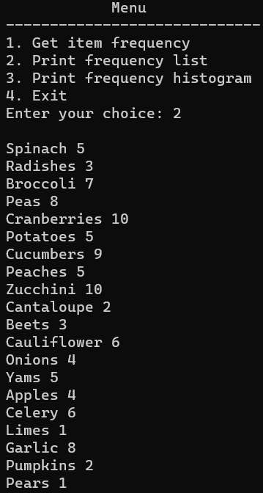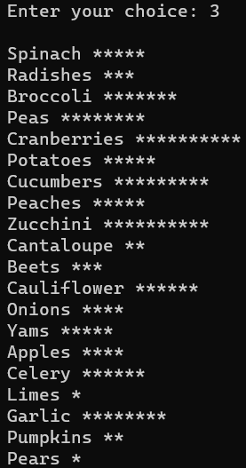

* + Exit: The program will save the frequency data to a file (e.g., "frequency.dat") and terminate the execution.

In closing, this program demonstrates effective use of C++ features, such as classes, functions, and file I/O, which contribute to a clean and efficient design. The program reads a list of items from a file, calculates their frequencies, and offers various ways to display and save the frequency information.